**Aint253 – Observatory escape room design document**

**User story map-**

**(Live board -** <https://miro.com/app/board/o9J_kwGDa3c=/>)

­

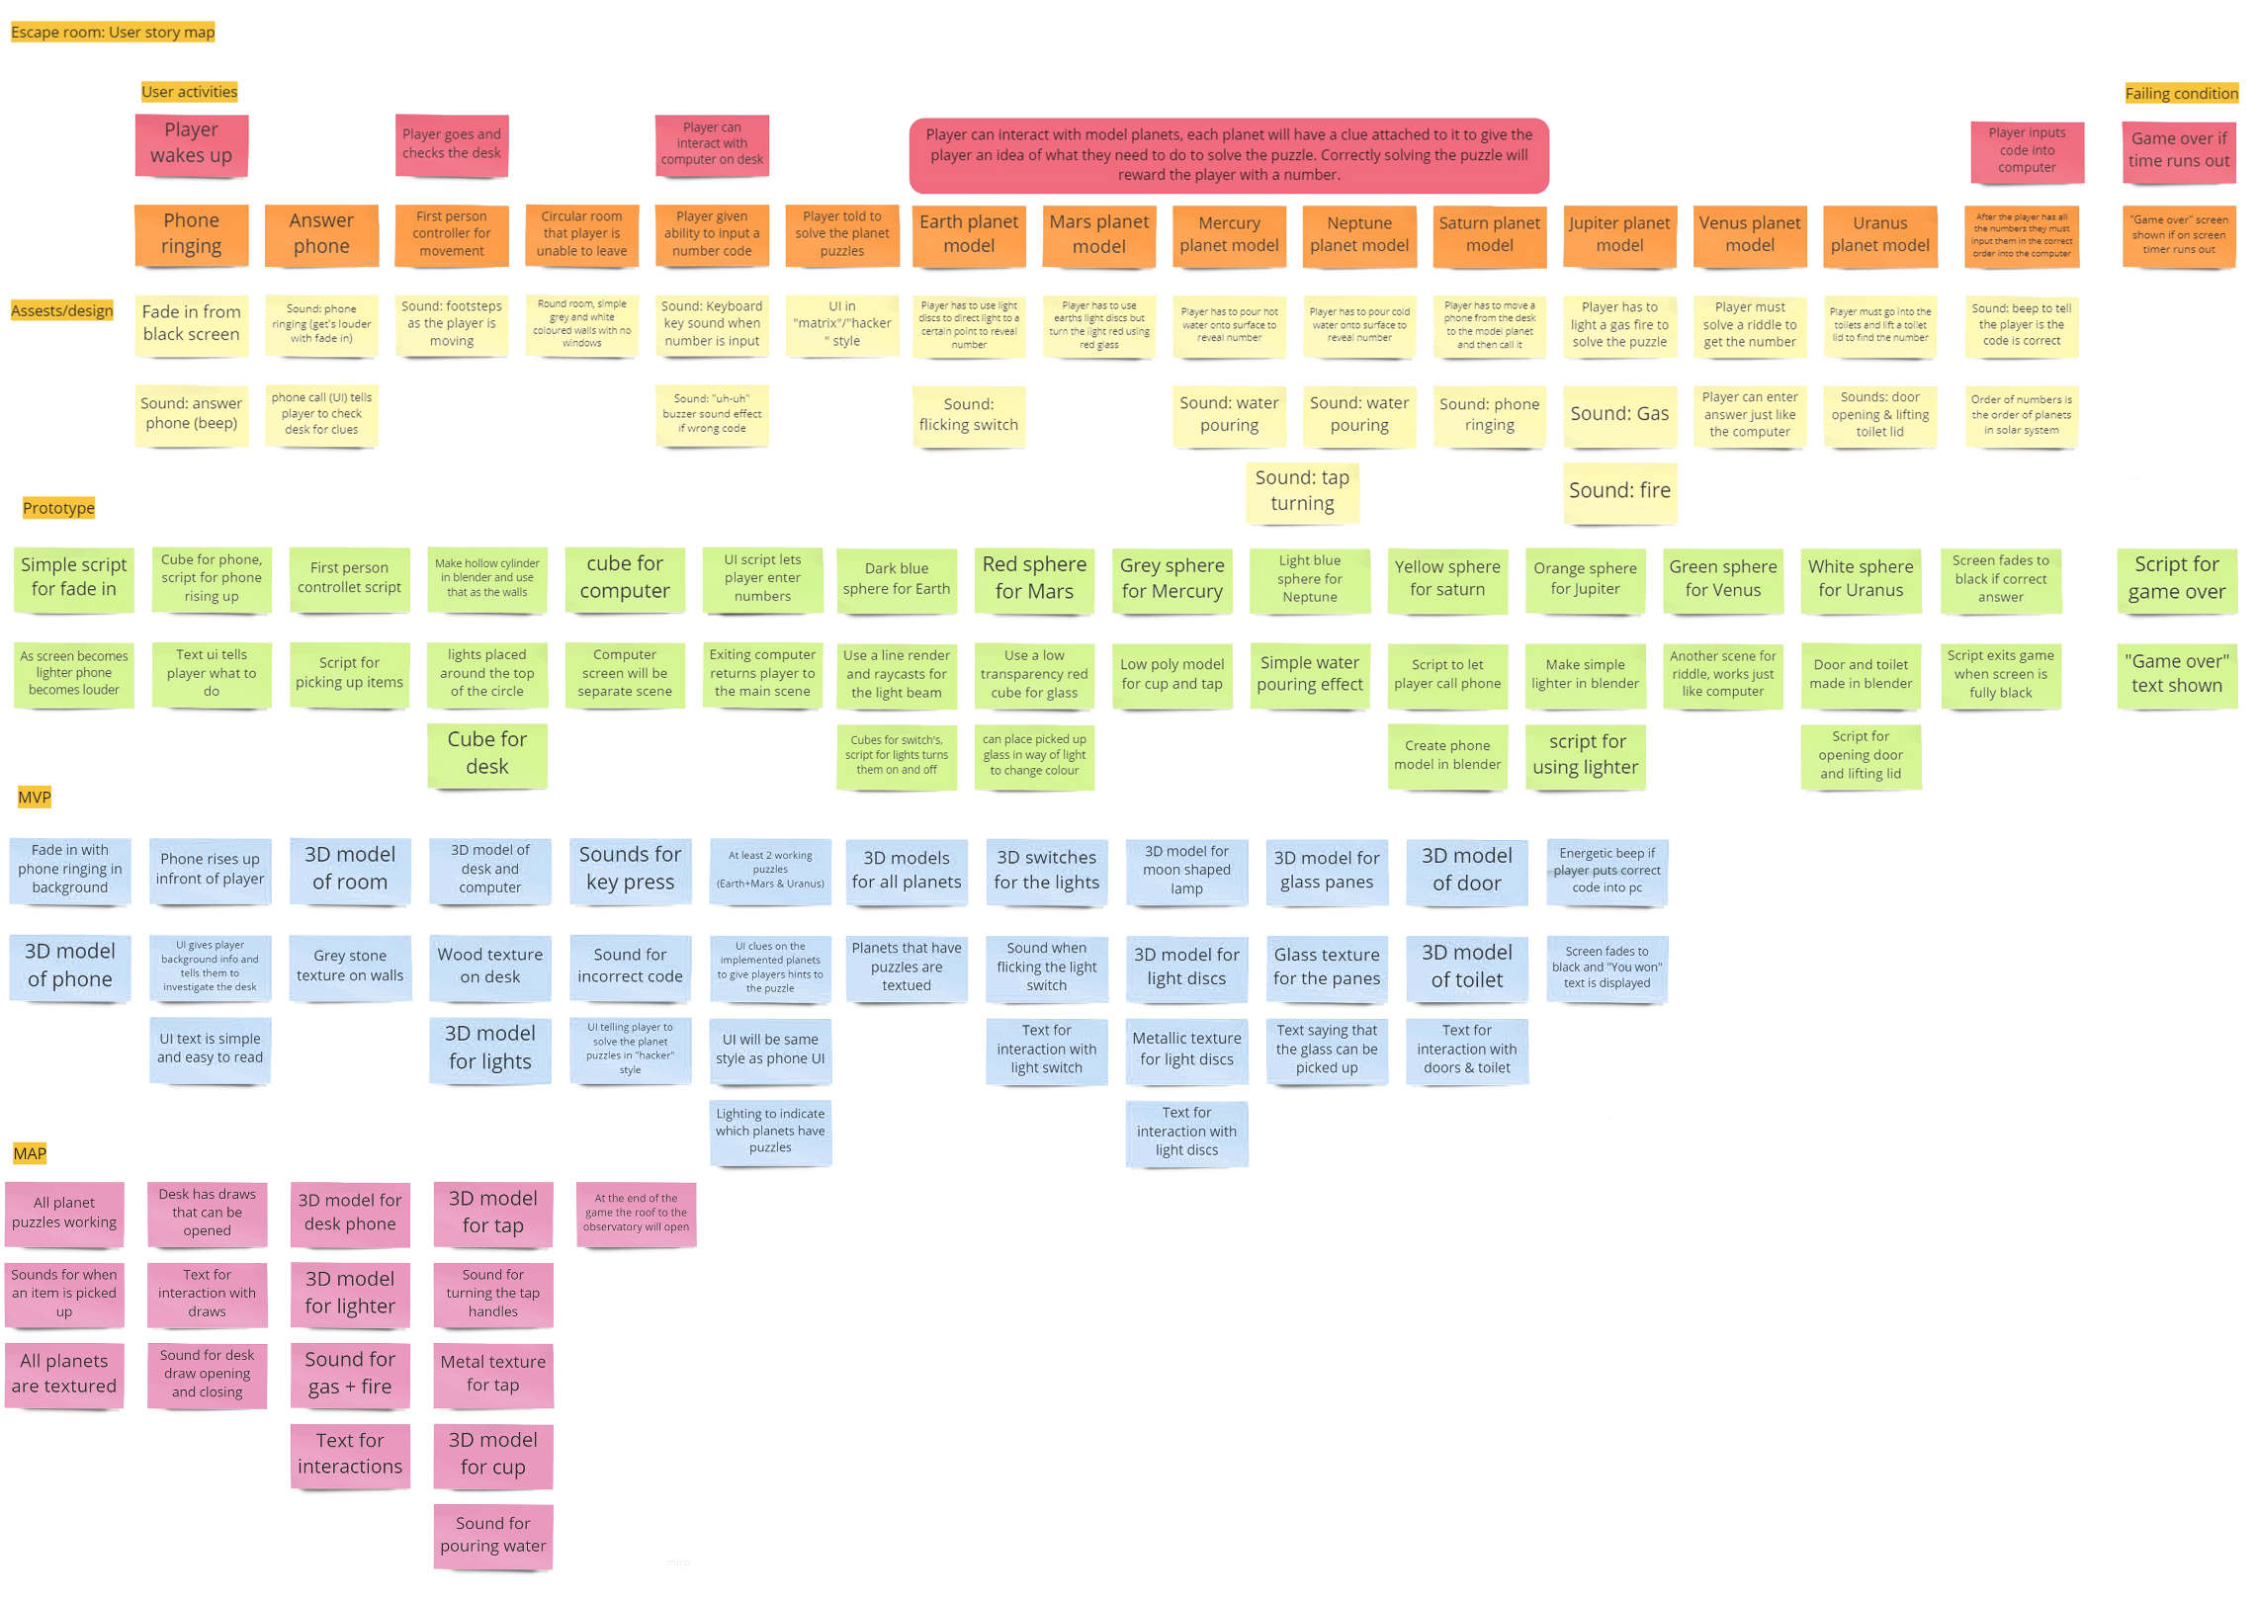

**Mood boards –**

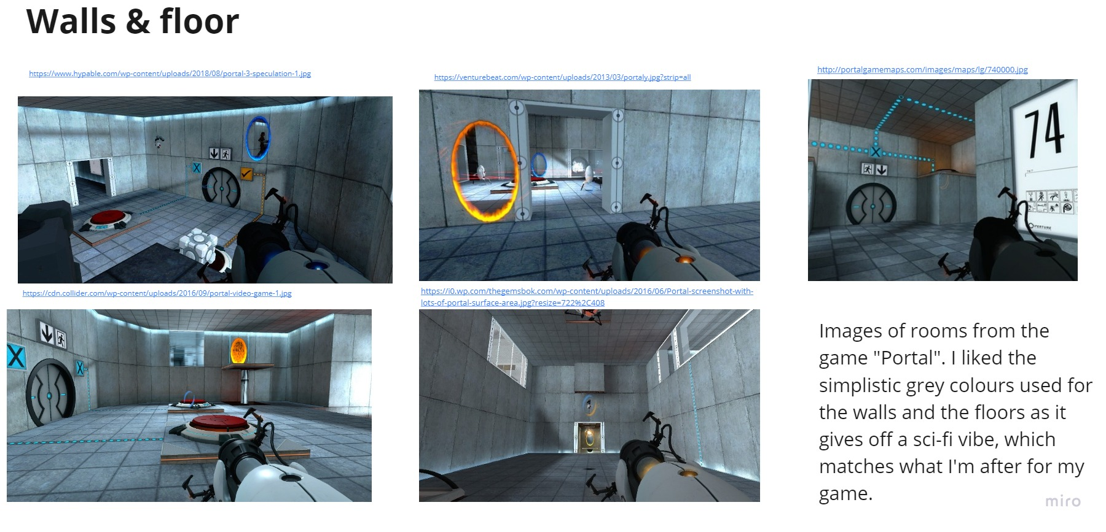

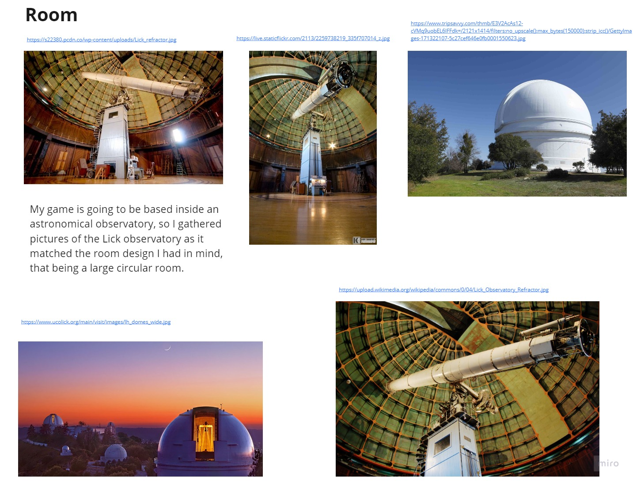

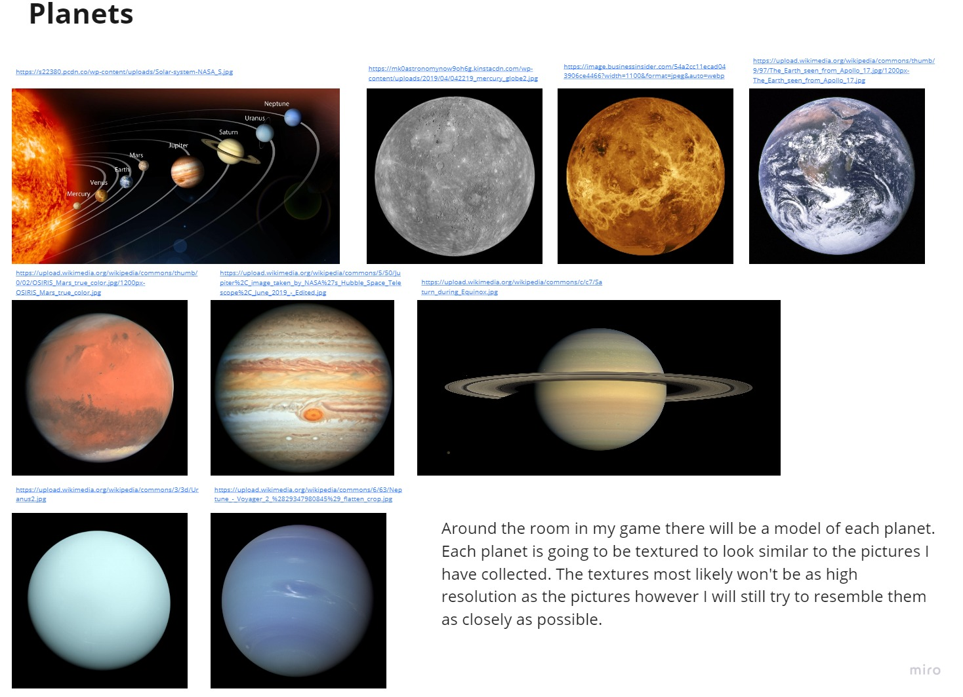

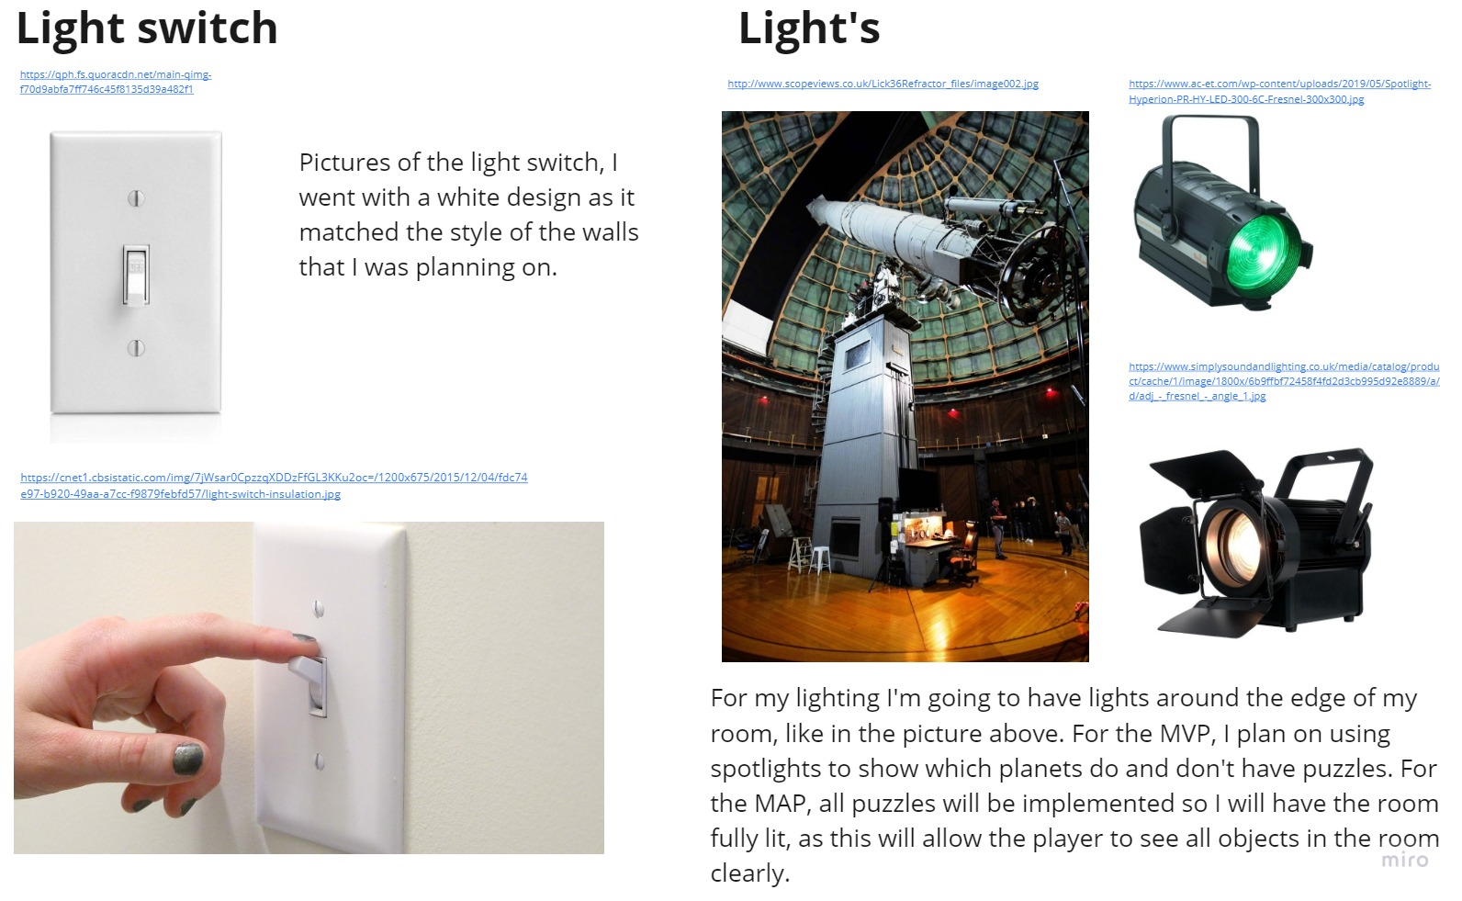

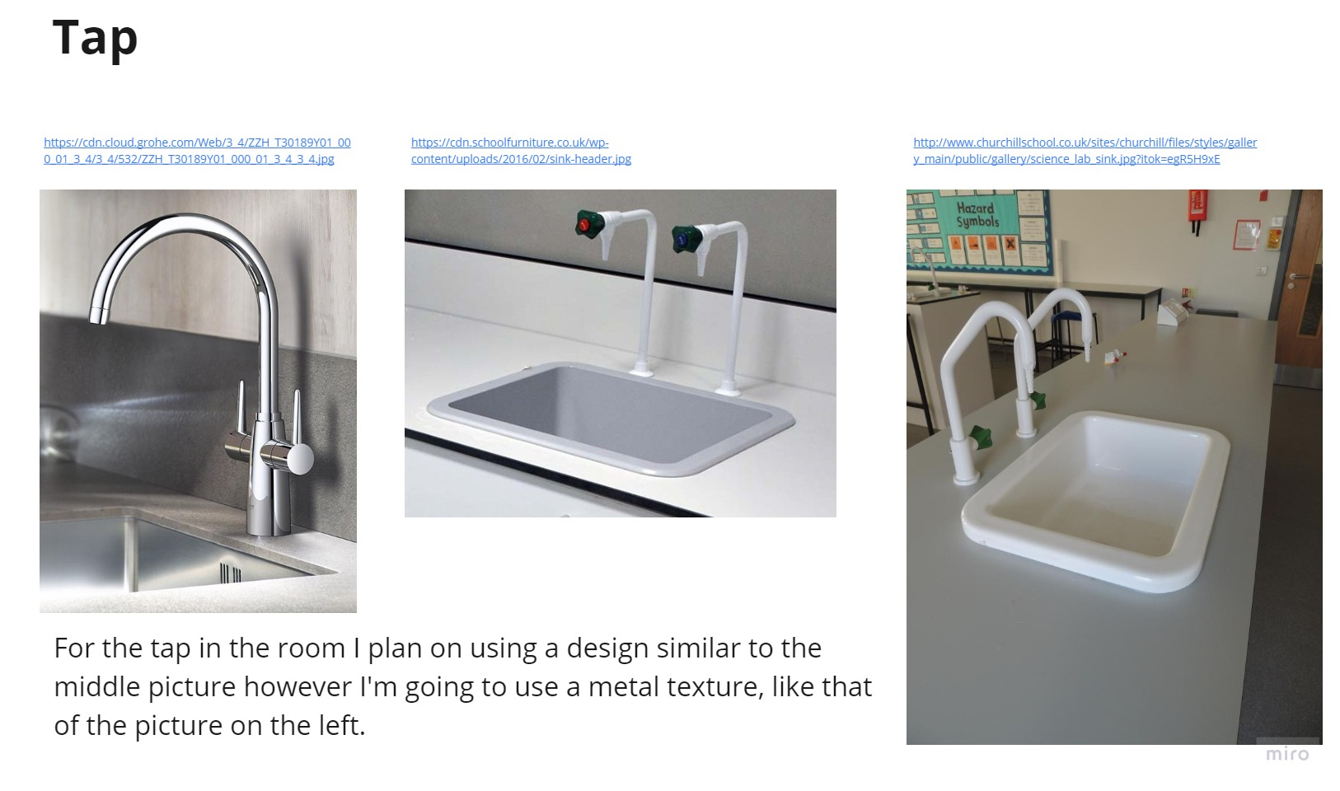

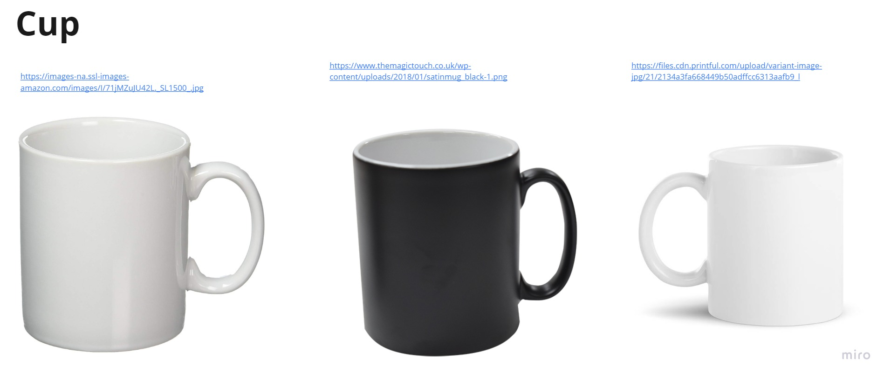

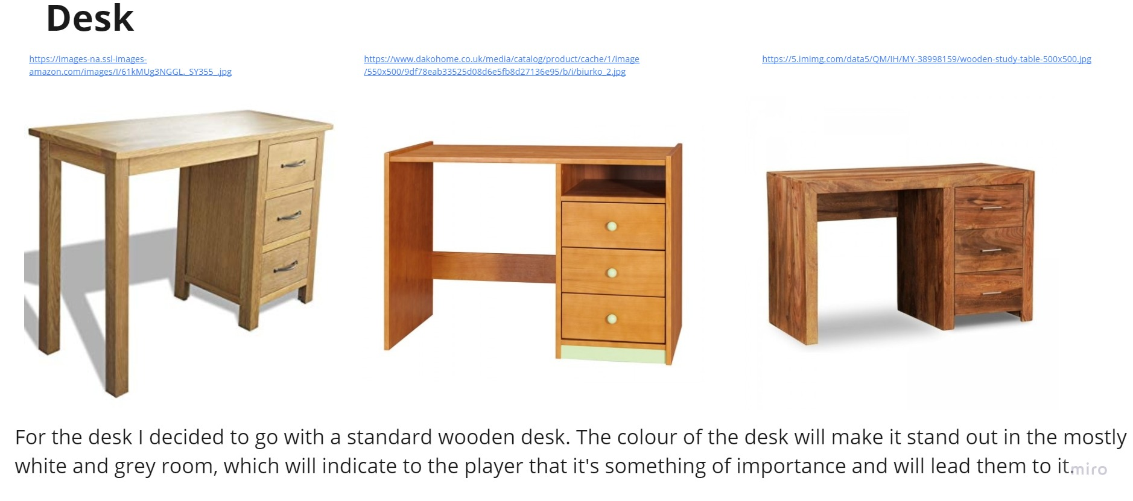

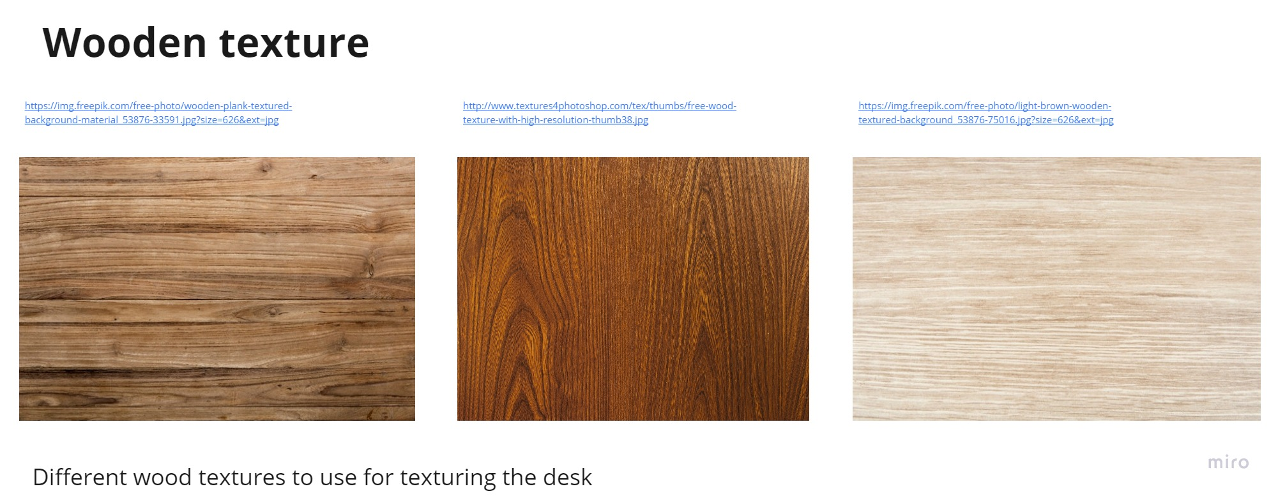

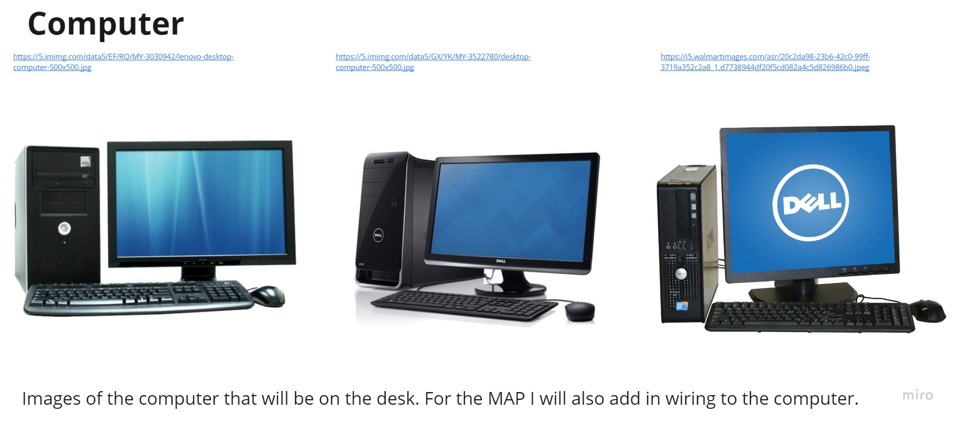

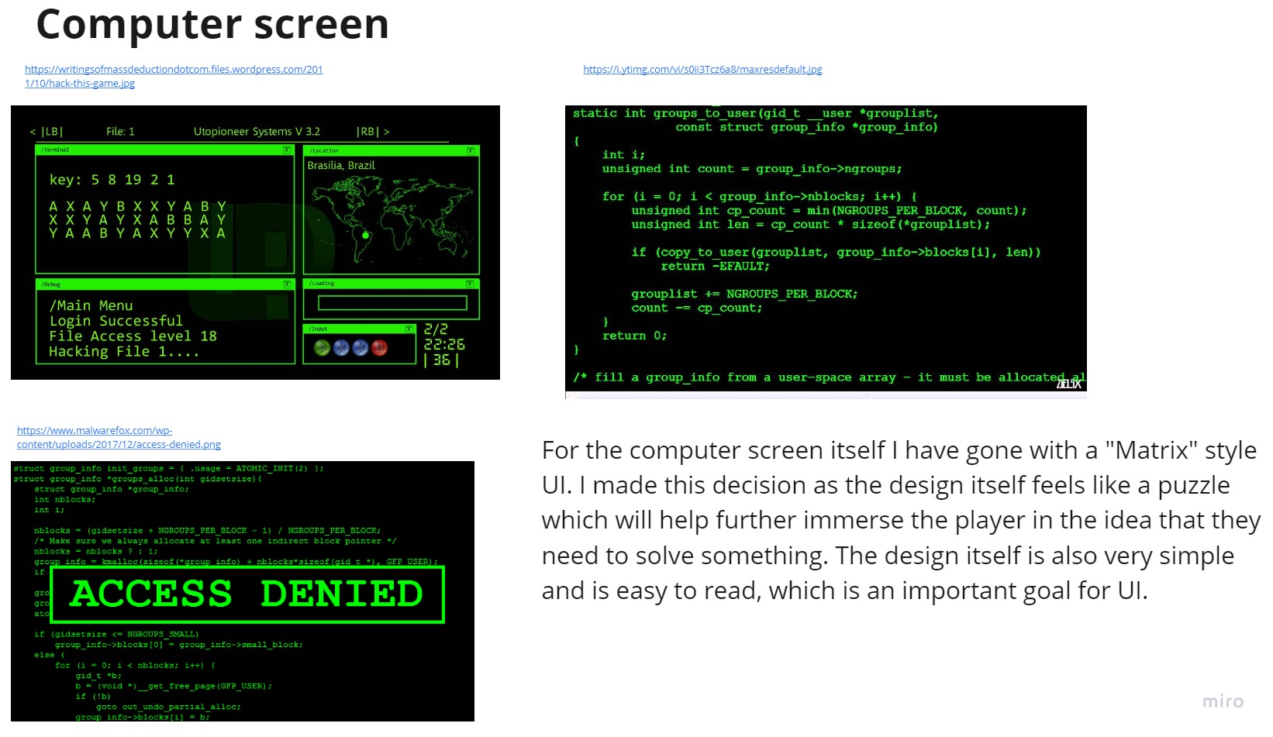

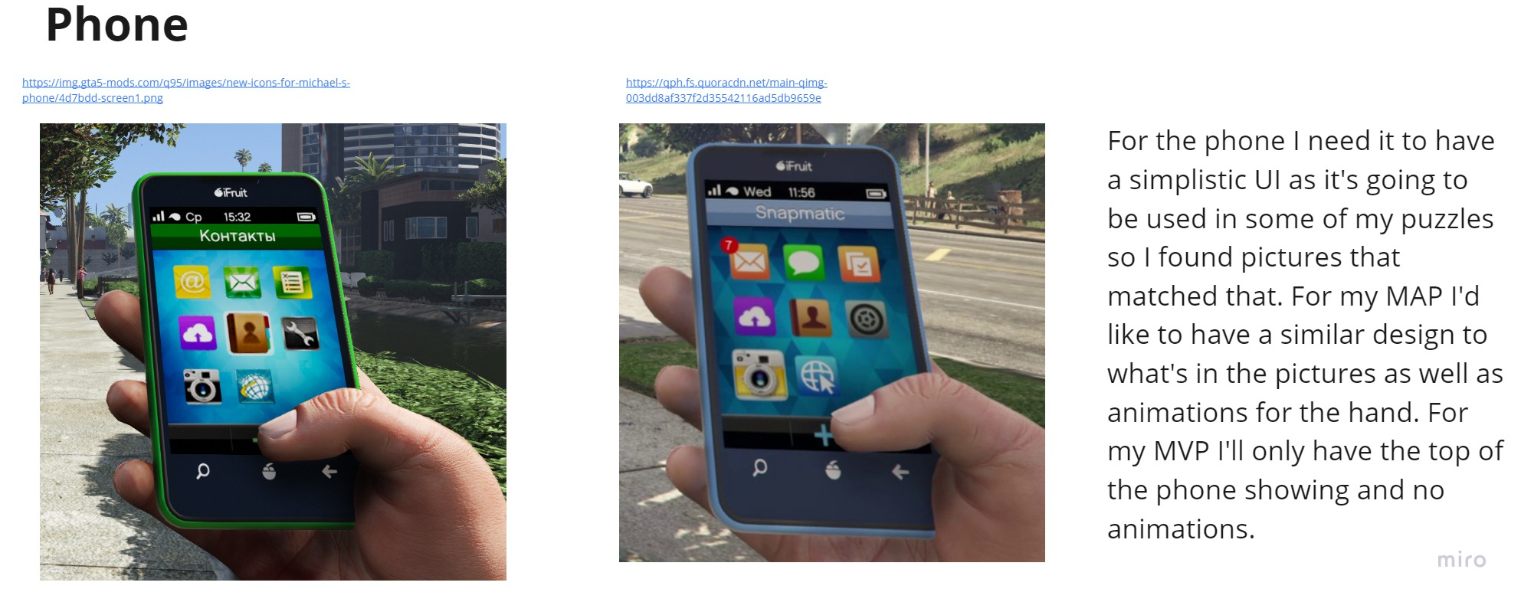

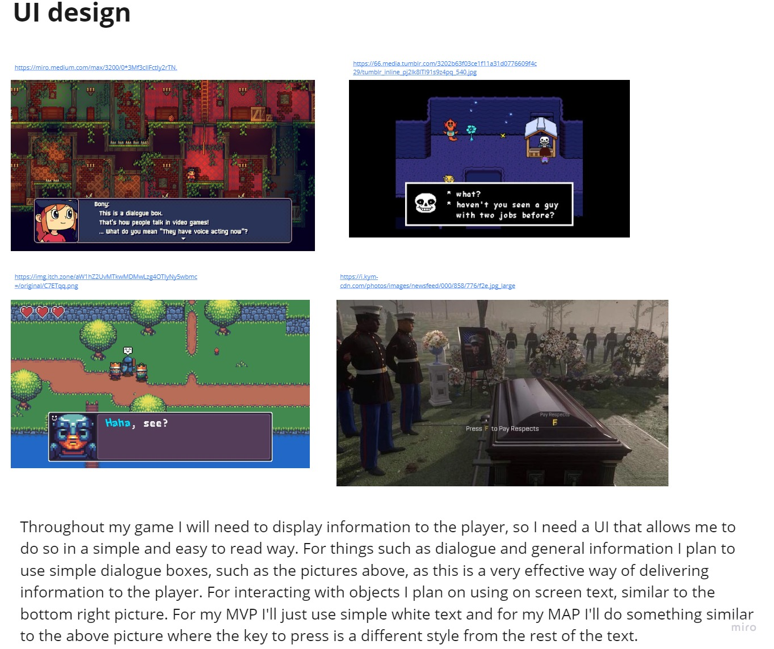

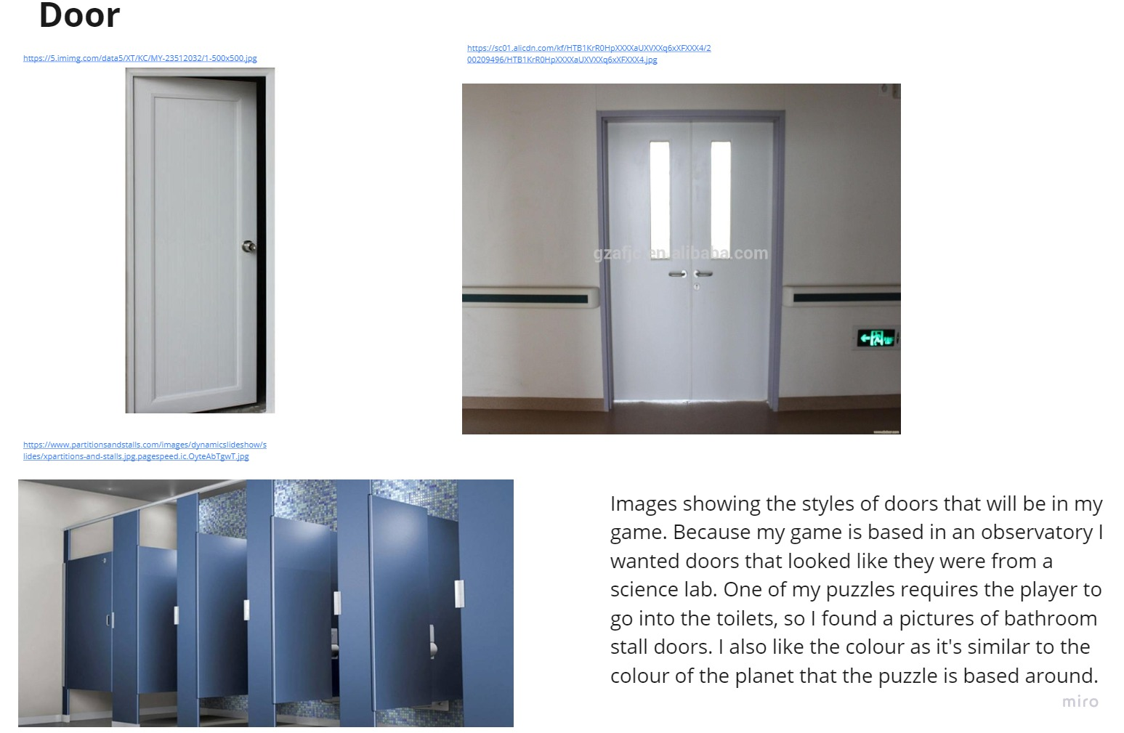

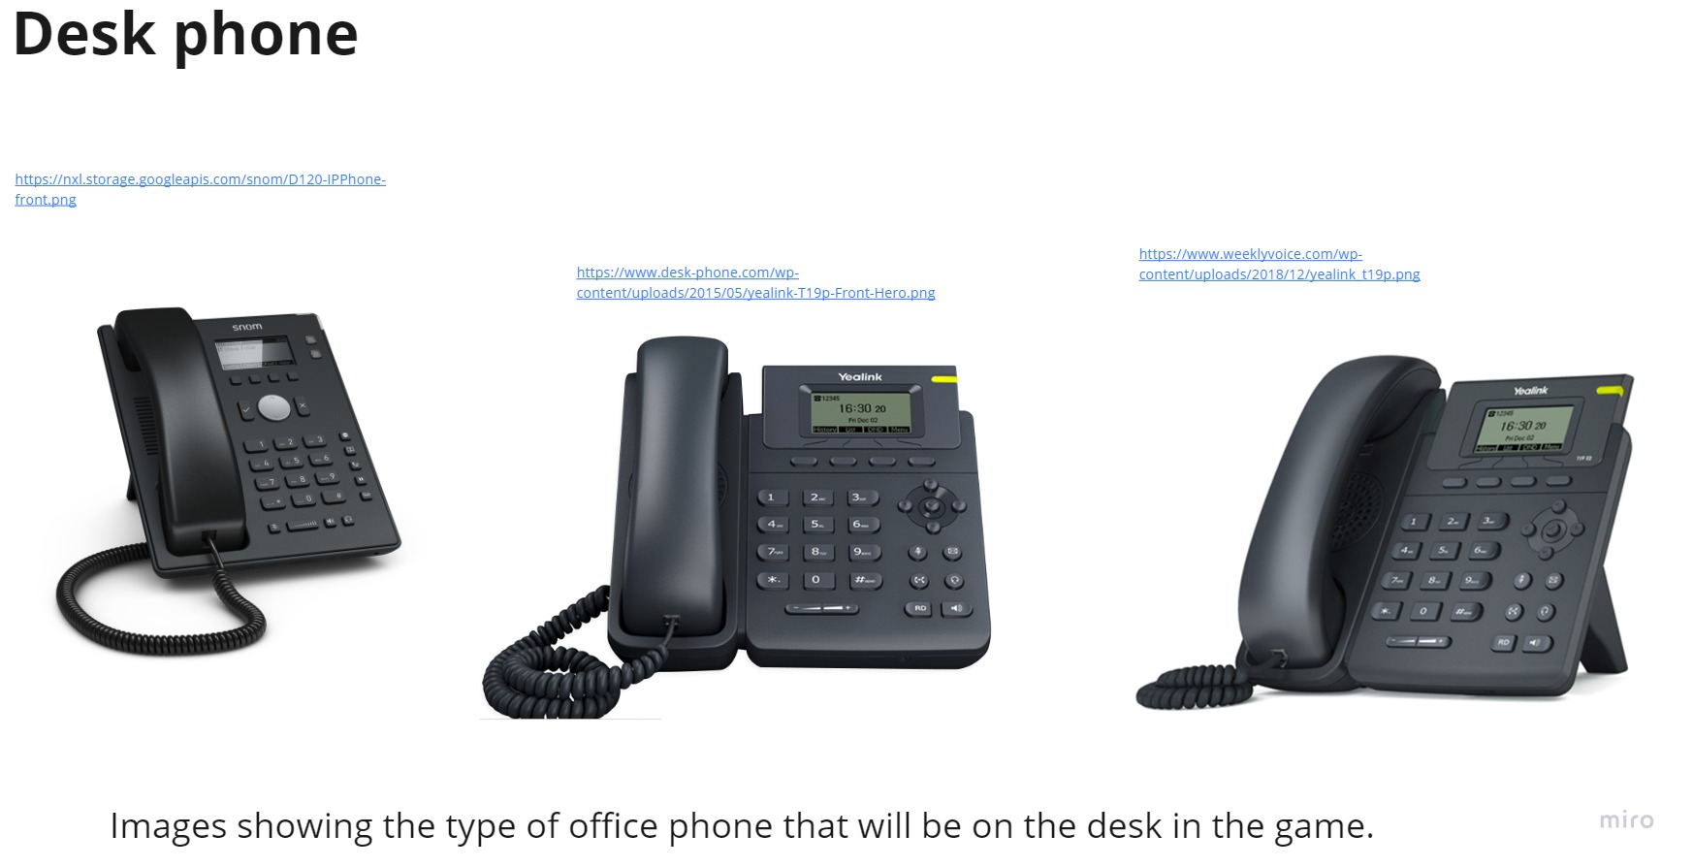

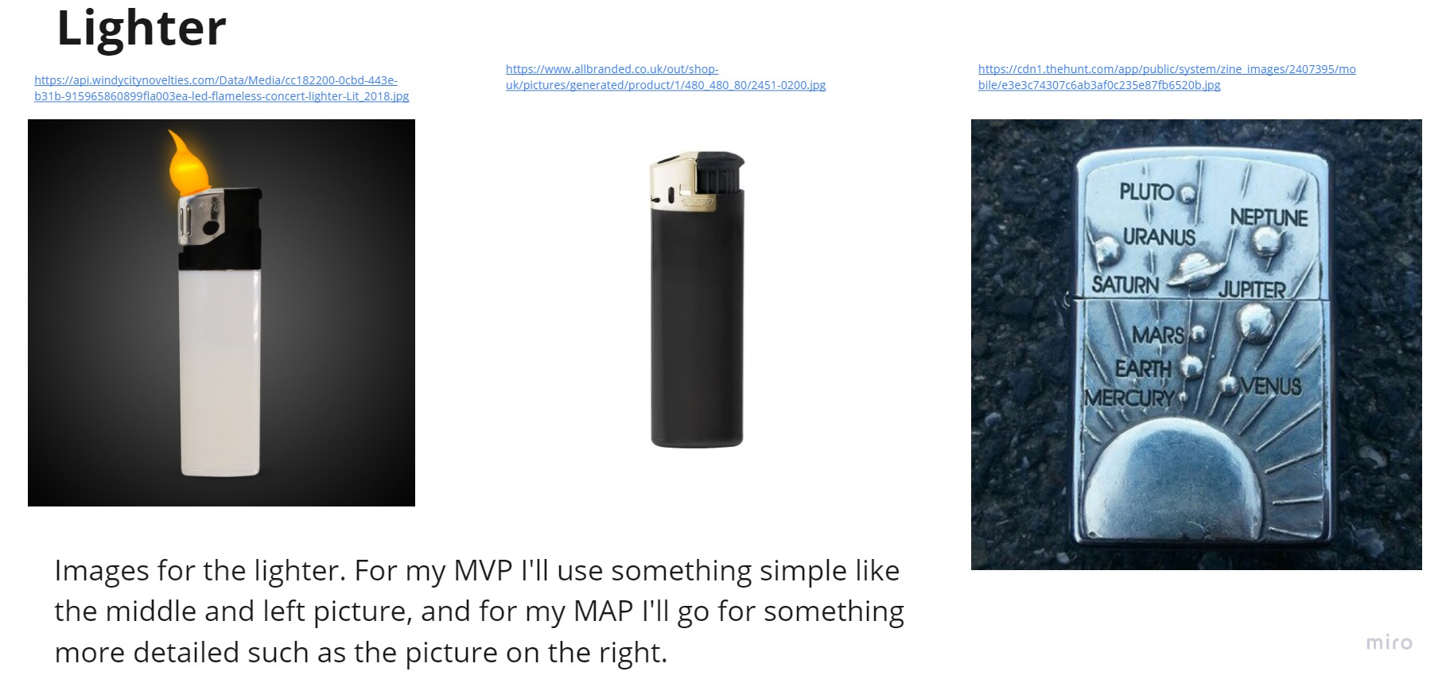

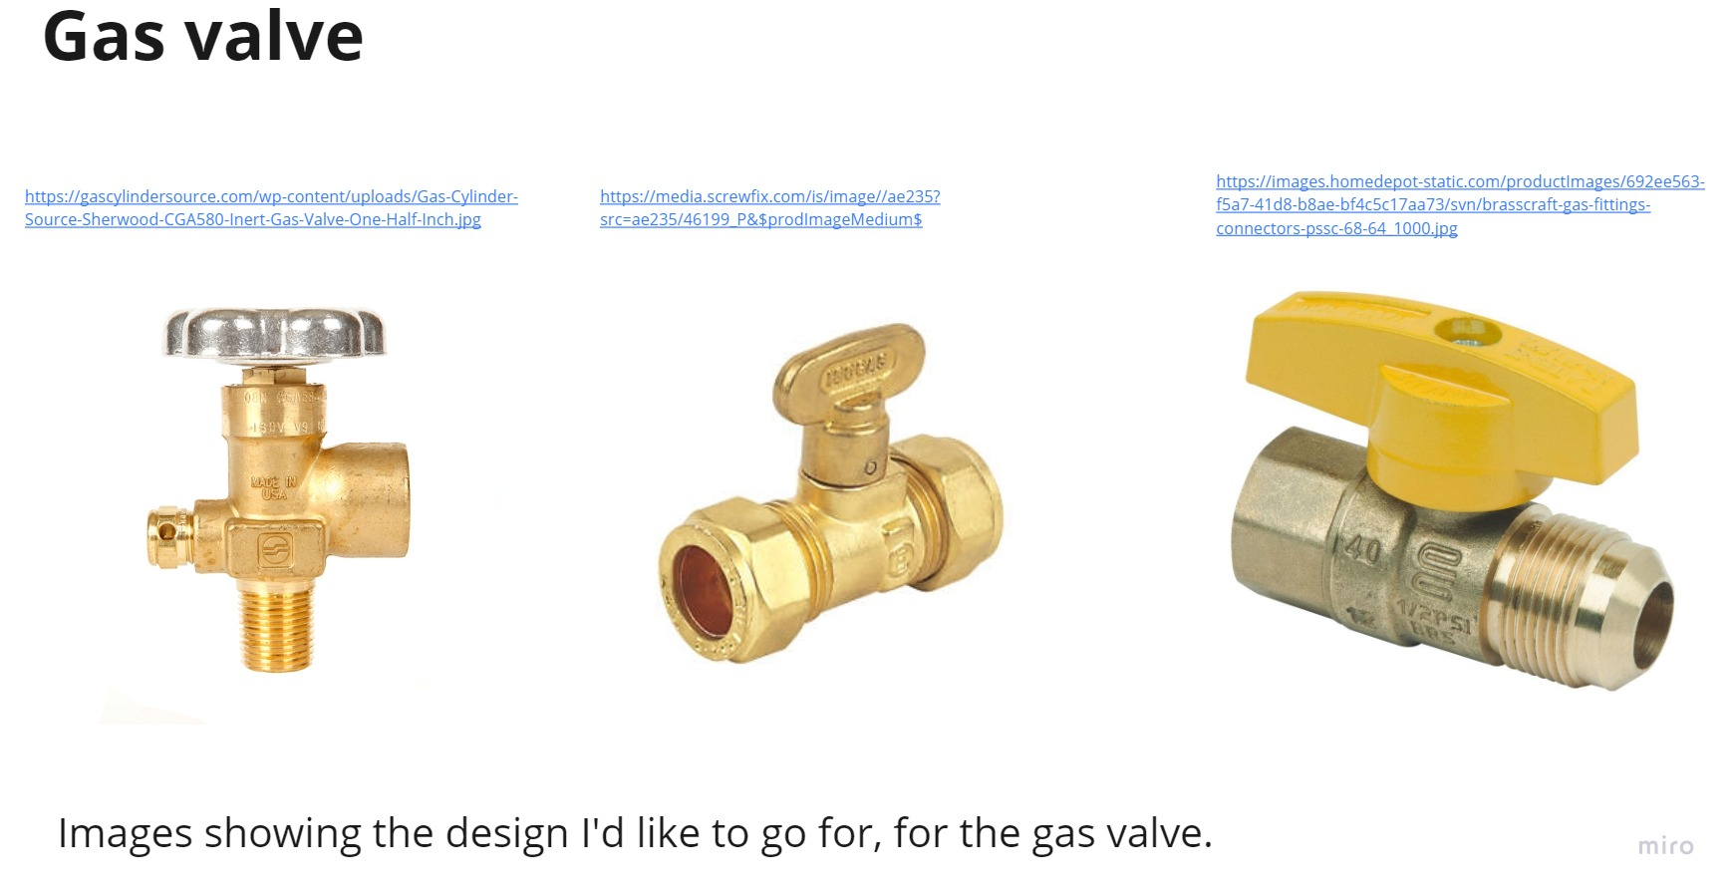

**Floor plan**

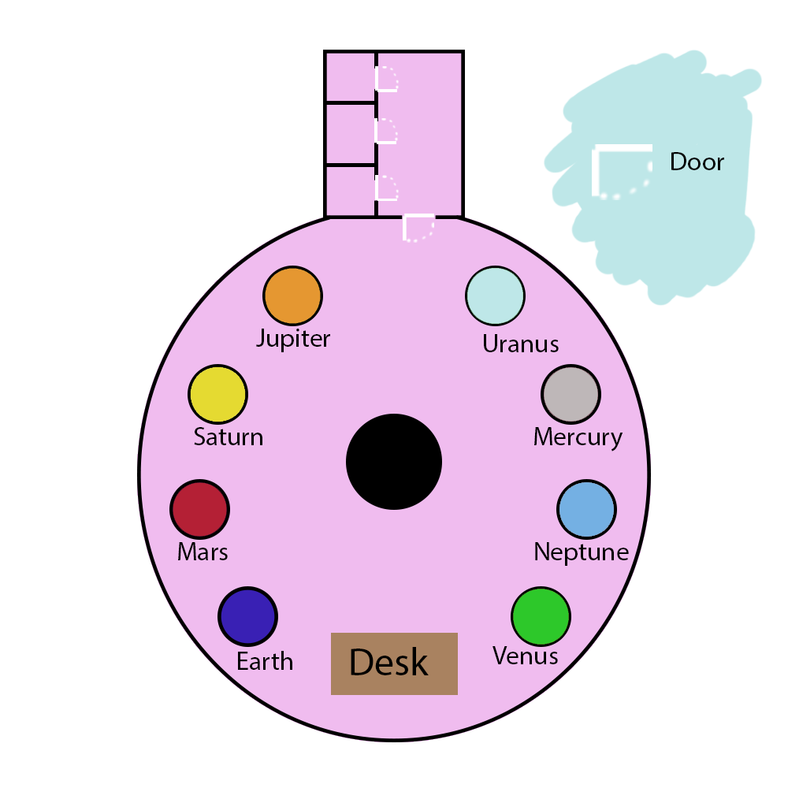

**Observatory escape room – Puzzle design**

For my escape room I decided to base my puzzles around the planets in our solar system. I took one aspect of each planet and designed the puzzles around those aspects. Each puzzle will give the player a number when completed. The player will need all the numbers in order to complete the final puzzle.

Mercury & Neptune

Mercury is the closest planet to the sun, and Neptune is the furthest away. This results in Mercury being the hottest planet in our solar system and Neptune being the coldest, so I decided to base the puzzles around these two planets on heat. Next to the planets there will be a tap and a cup. The player will have to fill the cup with cold water and pour it onto a small platform next to Neptune to reveal the number. The player will also have to do the same thing but with hot water for Mercury.

Earth & Mars

For Earth I had the idea of using the moon in some way. I decided to go with a light reflection puzzle, where the moon is a lamp that emits light. For the puzzle the player has to turn off the main lights in the room so that they can see the light from the moon lamp, then they need to spin light discs so that the light ends up on a certain point on a wall, revealing the number. I decided to also use this concept for Mars, but with Mars being known as the “Red planet”, the player must use some stained glass to turn the light red or else the number can’t be seen.

Saturn

Saturn is a planet known for its rings. I decided to take the idea of rings and do a play on words. For the puzzle the player will have to take a phone they find on the desk in the room and place it next to the planet, then they will need to call the phone. The phone will then “Ring”, which will solve the puzzle and award the player the number.

Jupiter

Jupiter is a gas giant and the largest planet in our solar system. I decided to use the idea of gas for its related puzzle. The planet will have four buttons that need to be pressed in a certain order to solve the puzzle, to find what the correct order is the player will have to turn on a gas valve that’s next to the planet and then use a lighter that’s found in the desk draw to light a fire inside the model. The light from the fire will then reveal the correct order to the player.

Venus

The planet Venus is named after the Roman goddess of love, so I decide to make the puzzle a riddle about love that the player has solve.

Uranus

For Uranus I decided to make the puzzle a joke. The player will have to go into the toilets, where under one of the seats is the number.

Final Code

The final puzzle requires the player to enter all the numbers from the puzzles, into a computer in a correct order. The order for the numbers is the order of the planets in our solar system, starting closest to the sun and going back, so the first number you put in is the number from Mercury’s puzzle, the second number being from Venus’s and so on. To help the player there will be a poster behind them that shows the planets in order.

**Sound design**

Opening door

For the door opening sound I will need the sound of a handle being turned and the door opening. Fortunately, my door fits this perfectly so I can just record the sound of my door.

Phone ringing

The phone ringing will just be a simple generic phone ring, something similar to this <https://www.youtube.com/watch?v=f-g0hkNsZcc>. I will then take the sound into Audacity and edit it into a loop.

Walking

My game takes place in a big open room, so for the footsteps of the player there will need to be some echo on it to make it immersive. I’ll take one of the sounds from here, <https://www.youtube.com/watch?v=9g7uukgq0Fc>, and use audacity to give it the echoey feel I’m looking for.

Draw opening + Light switch

These are both very simple sounds that I can get from recording the light switch and drawers in my room. Because of how simple these sounds are I can probably import them straight into Unity without any editing in Audacity.

Water tap

The water tap sound will need to be a constant sound, so to achieve this I will record my tap whilst it’s on and then use audacity to edit it into a loop, which will constantly play in the scene until turned off.

Keyboard + computer sounds

For the keyboard key press sound I will simply record the sound of a key press on my keyboard and have it play whenever the player inputs a key. For the sounds the computer will make when the player inputs the code, the will use sounds similar to these <https://www.youtube.com/watch?v=worclOeTALw>. For my MAP I’d would also like to add some ambient computer sounds, these being fans that are constantly on but randomly rev up.

Gas + fire

For both of these sounds I can record my gas hob and then use audacity to edit them into the sound I want.

**Observatory escape room references**

Hypable.com. (2019). [online] Available at: <https://www.hypable.com/wp-content/uploads/2018/08/portal-3-speculation-1.jpg> [Accessed 26 Oct. 2019].

Venturebeat.com. (2019). [online] Available at: <https://venturebeat.com/wp-content/uploads/2013/03/portaly.jpg?strip=all> [Accessed 26 Oct. 2019].

Portalgamemaps.com. (2019). [online] Available at: <http://portalgamemaps.com/images/maps/lg/740000.jpg> [Accessed 26 Oct. 2019].

Collider.com. (2019). [online] Available at: <https://cdn.collider.com/wp-content/uploads/2016/09/portal-video-game-1.jpg> [Accessed 26 Oct. 2019].

Wp.com. (2019). [online] Available at: <https://i0.wp.com/thegemsbok.com/wp-content/uploads/2016/06/Portal-screenshot-with-lots-of-portal-surface-area.jpg?resize=722%2C408> [Accessed 26 Oct. 2019].

Pcdn.co. (2014). [online] Available at: <https://s22380.pcdn.co/wp-content/uploads/Lick_refractor.jpg> [Accessed 26 Oct. 2019].

Staticflickr.com. (2019). [online] Available at: <https://live.staticflickr.com/2113/2259738219_335f707014_z.jpg> [Accessed 26 Oct. 2019].

Tripsavvy.com. (2019). [online] Available at: <https://www.tripsavvy.com/thmb/E3V2AcAs12-cVMq9uobEL6IFFdk=/2121x1414/filters:no_upscale():max_bytes(150000):strip_icc()/GettyImages-171322107-5c27cef646e0fb0001550623.jpg> [Accessed 26 Oct. 2019].

Ucolick.org. (2017). [online] Available at: <https://www.ucolick.org/main/visit/images/lh_domes_wide.jpg> [Accessed 26 Oct. 2019].

Wikimedia.org. (2019). [online] Available at: <https://upload.wikimedia.org/wikipedia/commons/0/04/Lick_Observatory_Refractor.jpg> [Accessed 26 Oct. 2019].

Pcdn.co. (2018). [online] Available at: <https://s22380.pcdn.co/wp-content/uploads/Solar-system-NASA_S.jpg> [Accessed 26 Oct. 2019].

Kinstacdn.com. (2019). [online] Available at: <https://mk0astronomynow9oh6g.kinstacdn.com/wp-content/uploads/2019/04/042219_mercury_globe2.jpg> [Accessed 26 Oct. 2019].

Businessinsider.com. (2019). [online] Available at: <https://image.businessinsider.com/54a2cc11ecad043906ce4466?width=1100&format=jpeg&auto=webp> [Accessed 26 Oct. 2019].

Wikimedia.org. (2019). [online] Available at: <https://upload.wikimedia.org/wikipedia/commons/thumb/9/97/The_Earth_seen_from_Apollo_17.jpg/1200px-The_Earth_seen_from_Apollo_17.jpg> [Accessed 26 Oct. 2019].

Wikimedia.org. (2019). [online] Available at: <https://upload.wikimedia.org/wikipedia/commons/thumb/0/02/OSIRIS_Mars_true_color.jpg/1200px-OSIRIS_Mars_true_color.jpg> [Accessed 26 Oct. 2019].

Wikimedia.org. (2019). [online] Available at: <https://upload.wikimedia.org/wikipedia/commons/5/50/Jupiter%2C_image_taken_by_NASA%27s_Hubble_Space_Telescope%2C_June_2019_-_Edited.jpg> [Accessed 26 Oct. 2019].

Wikimedia.org. (2019). [online] Available at: <https://upload.wikimedia.org/wikipedia/commons/c/c7/Saturn_during_Equinox.jpg> [Accessed 26 Oct. 2019].

Wikimedia.org. (2019). [online] Available at: <https://upload.wikimedia.org/wikipedia/commons/3/3d/Uranus2.jpg> [Accessed 26 Oct. 2019].

Wikimedia.org. (2019). [online] Available at: <https://upload.wikimedia.org/wikipedia/commons/6/63/Neptune_-_Voyager_2_%2829347980845%29_flatten_crop.jpg> [Accessed 26 Oct. 2019].

Quoracdn.net. (2019). [online] Available at: <https://qph.fs.quoracdn.net/main-qimg-f70d9abfa7ff746c45f8135d39a482f1> [Accessed 26 Oct. 2019].

Cbsistatic.com. (2019). [online] Available at: <https://cnet1.cbsistatic.com/img/7jWsar0CpzzqXDDzFfGL3KKu2oc=/1200x675/2015/12/04/fdc74e97-b920-49aa-a7cc-f9879febfd57/light-switch-insulation.jpg> [Accessed 26 Oct. 2019].

Scopeviews.co.uk. (2019). [online] Available at: <http://www.scopeviews.co.uk/Lick36Refractor_files/image002.jpg> [Accessed 26 Oct. 2019].

Ac-et.com. (2019). [online] Available at: <https://www.ac-et.com/wp-content/uploads/2019/05/Spotlight-Hyperion-PR-HY-LED-300-6C-Fresnel-300x300.jpg> [Accessed 26 Oct. 2019].

Simplysoundandlighting.co.uk. (2019). [online] Available at: <https://www.simplysoundandlighting.co.uk/media/catalog/product/cache/1/image/1800x/6b9ffbf72458f4fd2d3cb995d92e8889/a/d/adj_-_fresnel_-_angle_1.jpg> [Accessed 26 Oct. 2019].

Grohe.com. (2019). [online] Available at: <https://cdn.cloud.grohe.com/Web/3_4/ZZH_T30189Y01_000_01_3_4/3_4/532/ZZH_T30189Y01_000_01_3_4_3_4.jpg> [Accessed 27 Oct. 2019].

Schoolfurniture.co.uk. (2019). [online] Available at: <https://cdn.schoolfurniture.co.uk/wp-content/uploads/2016/02/sink-header.jpg> [Accessed 27 Oct. 2019].

Churchillschool.co.uk. (2019). [online] Available at: <http://www.churchillschool.co.uk/sites/churchill/files/styles/gallery_main/public/gallery/science_lab_sink.jpg?itok=egR5H9xE> [Accessed 27 Oct. 2019].

Ssl-images-amazon.com. (2019). [online] Available at: <https://images-na.ssl-images-amazon.com/images/I/71jMZuJU42L._SL1500_.jpg> [Accessed 27 Oct. 2019].

Themagictouch.co.uk. (2019). [online] Available at: <https://www.themagictouch.co.uk/wp-content/uploads/2018/01/satinmug_black-1.png> [Accessed 27 Oct. 2019].

Printful.com. (2019). [online] Available at: <https://files.cdn.printful.com/upload/variant-image-jpg/21/2134a3fa668449b50adffcc6313aafb9_l> [Accessed 27 Oct. 2019].

Ssl-images-amazon.com. (2019). [online] Available at: <https://images-na.ssl-images-amazon.com/images/I/61kMUg3NGGL._SY355_.jpg> [Accessed 27 Oct. 2019].

Imimg.com. (2019). [online] Available at: <https://5.imimg.com/data5/QM/IH/MY-38998159/wooden-study-table-500x500.jpg> [Accessed 27 Oct. 2019].

Freepik.com. (2019). [online] Available at: <https://img.freepik.com/free-photo/wooden-plank-textured-background-material_53876-33591.jpg?size=626&ext=jpg> [Accessed 27 Oct. 2019].

Textures4photoshop.com. (2019). [online] Available at: <http://www.textures4photoshop.com/tex/thumbs/free-wood-texture-with-high-resolution-thumb38.jpg> [Accessed 27 Oct. 2019].

Freepik.com. (2019). [online] Available at: <https://img.freepik.com/free-photo/light-brown-wooden-textured-background_53876-75016.jpg?size=626&ext=jpg> [Accessed 27 Oct. 2019].

Imimg.com. (2019). [online] Available at: <https://5.imimg.com/data5/EF/RQ/MY-3030942/lenovo-desktop-computer-500x500.jpg> [Accessed 27 Oct. 2019].

Imimg.com. (2019). [online] Available at: <https://5.imimg.com/data5/GX/YK/MY-3522780/desktop-computer-500x500.jpg> [Accessed 27 Oct. 2019].

Walmartimages.com. (2019). [online] Available at: <https://i5.walmartimages.com/asr/20c2da98-23b6-42c0-99ff-3719a352c2a8_1.d7738944df20f5cd082a4c5d826986b0.jpeg> [Accessed 27 Oct. 2019].

Wordpress.com. (2011). [online] Available at: <https://writingsofmassdeductiondotcom.files.wordpress.com/2011/10/hack-this-game.jpg> [Accessed 27 Oct. 2019].

Ytimg.com. (2019). [online] Available at: <https://i.ytimg.com/vi/s0ii3Tcz6a8/maxresdefault.jpg> [Accessed 27 Oct. 2019].

Malwarefox.com. (2019). [online] Available at: <https://www.malwarefox.com/wp-content/uploads/2017/12/access-denied.png> [Accessed 27 Oct. 2019].

Gta5-mods.com. (2019). [online] Available at: <https://img.gta5-mods.com/q95/images/new-icons-for-michael-s-phone/4d7bdd-screen1.png> [Accessed 28 Oct. 2019].

Quoracdn.net. (2019). [online] Available at: <https://qph.fs.quoracdn.net/main-qimg-003dd8af337f2d35542116ad5db9659e> [Accessed 28 Oct. 2019].

Medium.com. (2019). [online] Available at: [https://miro.medium.com/max/3200/0*3Mf3cIlFctIy2rTN](https://miro.medium.com/max/3200/0*3Mf3cIlFctIy2rTN). [Accessed 28 Oct. 2019].

Tumblr.com. (2019). [online] Available at: <https://66.media.tumblr.com/3202b63f03ce1f11a31d0776609f4c29/tumblr_inline_pj2lk8lTl91s9z4pq_540.jpg> [Accessed 28 Oct. 2019].

Itch.zone. (2019). [online] Available at: <https://img.itch.zone/aW1hZ2UvMTkwMDMwLzg4OTIyNy5wbmc=/original/C7ETqq.png> [Accessed 28 Oct. 2019].

Kym-cdn.com. (2019). [online] Available at: <https://i.kym-cdn.com/photos/images/newsfeed/000/858/776/f2e.jpg_large> [Accessed 28 Oct. 2019].

Imimg.com. (2019). [online] Available at: <https://5.imimg.com/data5/XT/KC/MY-23512032/1-500x500.jpg> [Accessed 28 Oct. 2019].

Alicdn.com. (2019). [online] Available at: <https://sc01.alicdn.com/kf/HTB1KrR0HpXXXXaUXVXXq6xXFXXX4/200209496/HTB1KrR0HpXXXXaUXVXXq6xXFXXX4.jpg> [Accessed 28 Oct. 2019].

Partitionsandstalls.com. (2019). [online] Available at: <https://www.partitionsandstalls.com/images/dynamicslideshow/slides/xpartitions-and-stalls.jpg.pagespeed.ic.OyteAbTgwT.jpg> [Accessed 28 Oct. 2019].

Googleapis.com. (2019). [online] Available at: <https://nxl.storage.googleapis.com/snom/D120-IPPhone-front.png> [Accessed 28 Oct. 2019].

Desk-phone.com. (2019). [online] Available at: <https://www.desk-phone.com/wp-content/uploads/2015/05/yealink-T19p-Front-Hero.png> [Accessed 28 Oct. 2019].

Weeklyvoice.com. (2019). [online] Available at: <https://www.weeklyvoice.com/wp-content/uploads/2018/12/yealink_t19p.png> [Accessed 28 Oct. 2019].

Windycitynovelties.com. (2018). [online] Available at: <https://api.windycitynovelties.com/Data/Media/cc182200-0cbd-443e-b31b-915965860899fla003ea-led-flameless-concert-lighter-Lit_2018.jpg> [Accessed 29 Oct. 2019].

Allbranded.co.uk. (2019). [online] Available at: <https://www.allbranded.co.uk/out/shop-uk/pictures/generated/product/1/480_480_80/2451-0200.jpg> [Accessed 29 Oct. 2019].

Thehunt.com. (2019). [online] Available at: <https://cdn1.thehunt.com/app/public/system/zine_images/2407395/mobile/e3e3c74307c6ab3af0c235e87fb6520b.jpg> [Accessed 29 Oct. 2019].

Gascylindersource.com. (2019). [online] Available at: <https://gascylindersource.com/wp-content/uploads/Gas-Cylinder-Source-Sherwood-CGA580-Inert-Gas-Valve-One-Half-Inch.jpg> [Accessed 29 Oct. 2019].

Screwfix.com. (2019). [online] Available at: <https://media.screwfix.com/is/image//ae235?src=ae235/46199_P&$prodImageMedium$> [Accessed 29 Oct. 2019].

Homedepot-static.com. (2019). [online] Available at: <https://images.homedepot-static.com/productImages/692ee563-f5a7-41d8-b8ae-bf4c5c17aa73/svn/brasscraft-gas-fittings-connectors-pssc-68-64_1000.jpg> [Accessed 29 Oct. 2019].

Cell Phone Ringing Sound Effects. (2017). *YouTube*. Available at: <https://www.youtube.com/watch?v=f-g0hkNsZcc> [Accessed 28 Oct. 2019].

Footstep sound effects (walking sound effect). (2019). *YouTube*. Available at: <https://www.youtube.com/watch?v=9g7uukgq0Fc> [Accessed 28 Oct. 2019].

Correct sound effect and wrong sound effect. (2012). *YouTube*. Available at: <https://www.youtube.com/watch?v=worclOeTALw> [Accessed 28 Oct. 2019].